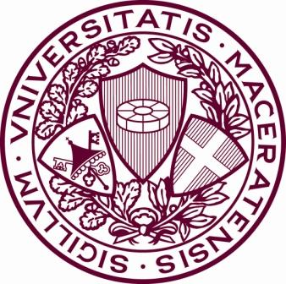
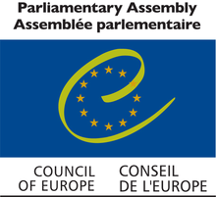
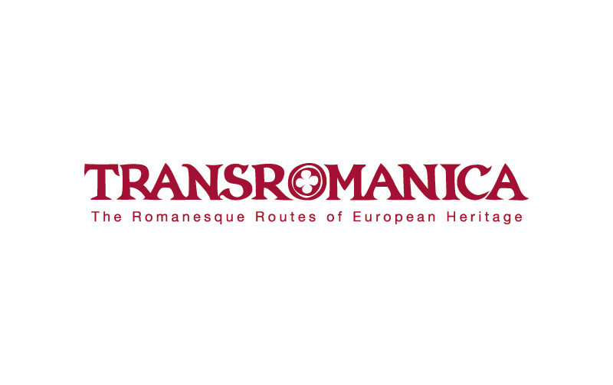
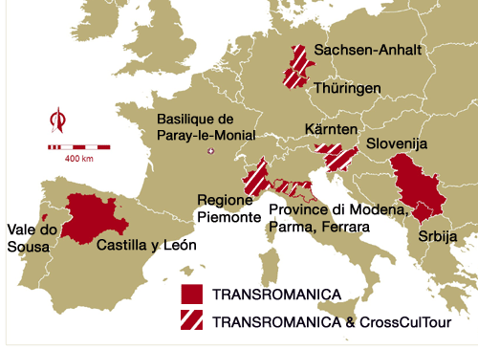
Caruso Antonela
Gaudioso Francesco
Lopez Marco
Pesce Daniela

Introduction
The TRANSROMANICA ROUTE is an International non-profit organization for supporting and fostering Europe’s Romanesque cultural heritage.
The Transromanica Cultural Route brings together a number of regions across Europe that house monuments related to the Romanesque period. During the eleventh and twelfth centuries, many religious buildings were constructed throughout Europe with architectural style, thus creating a "common language".
The route contains more than 45 Romanesque highlights, including many UNESCO Word Heritage sites such as the Collegiate Church of St Servatius in Quidlinburg, Wartburg Castle in Eisenach and Modena Cathedral. This route covers over 400 monumets in total spread across eight countries, and is not a physically continuos route, but rather a network of regions with Romanesque heritage.

The participants and the logic of project
The project started in 2003 as an EU INTERREG IIIB with five regions:
- Saxony-Anhalt (Germany);
- Thuringia (Germany);
- Slovenia;
- Carinthia (Austria);
- Province of Modena.
The application for a Major Cultural Route of Council of Europe was prepared in 2006, together with partners from France, Spain and Serbia. On 31 August 2007, Transromanica received official certification as a Major Cultural Route of the Council of the Europe. The first constitutional meeting of the Transromanica Association was held in November 2007 and subsequently became registered under the name “TRANSROMANICA”.
It is focused on a significant element of an European Cultural Heritage and as already developed a number of projects, particularly in the area of cultural tourism for enhancing the attractiveness of cities and regions as member of the network. This case study is based on an analysis of the central activities of the Route as a whole as well as a specific local analysis of one partner region (Vale do Sousa in Portugal). In this project there are many participating: Austria, France, Germany, Italy, Portugal (from 2009), Slovenia (until 2010), Spain and Serbia.

Objectives
The main objectives of the network Transromanica develop in various points :
• Further growth of the network , or expansion of the existing network , involving new regions and cities with characteristics of Roman culture ;
• To raise awareness on tourism marketing , or developing new attractiveness so as to immerse the visitor in the context Romanesque ;
• Opening of buildings;
• Qualification of members and employees by improving their skills in order to meet the various needs of visitors and make them share the experience ;
• Recovery of traditional products in order to diversify away from the gastronomic point of view and not associated with the various regions ;
• Create identity and promote volunteering ;
• Promote cultural events and art projects ;
•Establish public relations ;
•The use of new media such as social networks and new electronic communication systems ;
• Promote creative and fun activities for children, and activities to engage adults
Stakeholders
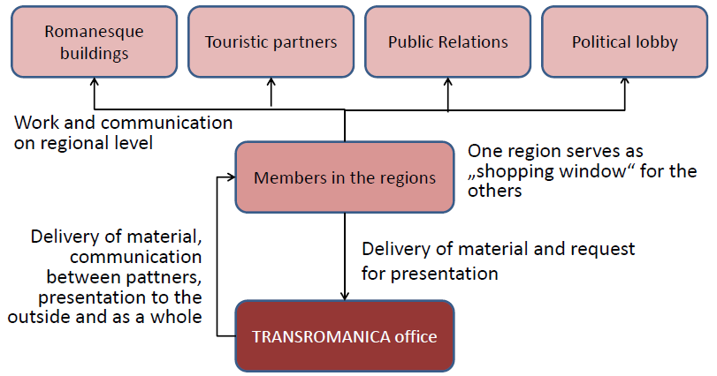
The cultural project is developed in two phases guided by a consortium of municipalities involved. The first phase consisted mainly of conservation measures for the restructuring and reconstruction of monuments to make them accessible to visitors. The second phase involved the development of a tourism product, which is the path that connects the various monuments. The project was supervised and financed by the public sector by creating a challenge for tourism development because public bodies are not allowed to make profits by pushing the consortium to collaborate with the private sector.
The structure:
The structure provide on overview of the structure of the association. The members are considered intermediaries between local partners and the international organization connecting Romanesque heritage sites. In addiction to this general structure, the association also has an executive committee (EC) and a scientific advisory board (SAB). The EC consists of three members who come together every two months to discuss recent developments. The SAB maintains a knowledge platform and its research projects support new programmes.



The CrossCulTour is another European project that includes Transromanica member in Austria, Germany, Italy and Slovenia. Members in France, Spain, Portugal and Serbia are not enigible to participate in this project since funding is provided under the Central Europe programme of the ERDF. The project runs from December 2008 until November 2011. The aim of project is “ to search for synergies, use former results and develoopcross-marketing approaches to address markets with competitive cultural tourism products together, thereby assisting small and medium-sized enterprises in creating employment, increasing regional income but also assuring sustainable knowledge and exchange”.

New Marketing activities
The Transromanica’s sites offers:
- Interactive maps;
- Audio guides in three different languages;
- Special edition for children.
Publications :
• Just Transromanica brochure material ;
• concerning Flyer (English, German , French, Italian , Slovenian, Serbian and Spanish) ;
• Booklet with the image (English, German , French, Italian and Slovene) ;
• Project leaflet (English, German , French, Italian and Slovene) ;
• Manual for sale ( in English).
Through the use of facebook and youtube were able to reach a wider audience.
In 2011 was made a sales manual, with the service offered by the regional tourism.

Training Seminaries
Transromanica has developed programs and training seminars . Seminars organized by Transromanica include :
- TRANSROMANICA Congress 2005 , Magdeburg ;
- Romanesque art as the origin of modern creativity 2008 Ejea de los Caballeros ;
- Roman art in the exemple de quelques buildings travers du harolias -en -Brionnais ", 2008,
Charolais en Briomiais ;
- Romanesque Architecture , 2008 La Clayette ;
- Making Visible the Holy 2008 Merseburg ;
- The Cathedral of Magdeburg, in the European context , 2009, Magdeburg.

Topics covered in the seminars are:
- Animation
- Entrepreneurship
- Arts and crafts
- Web design
There were also a number of specific activities in favor of SMEs , particularly in the tourism sector :
• Tourism Exchange :
• Meeting to create itineraries in 2010
• The training of tourist guides of Saxony - Anhalt in 2011

Merchandising activities
Products included in the range of souvenirs include:
- Books
- T-shirts
- DVDs
- Flax-growing kits
Local companies involved belong to a limited group of sectors
- Crafts
- Hotels
- Restaurants
- Designers

Methodology
The information of this project were collected through bibliographic research, a website analysis and interviews.
The website analysis was conducted using the website www.alexa.com

Conclusions
In order we can understand that the member countries of the project take leaflets and brochures that are written in the local language, while English is put in second place, it appears as a weak point. The partners are geographically isolated, which is why their relationships are limited and are used video conferencing. Reasons for these limitations are often underfunded. The majority of funds are allocated by the EU. The main areas of cooperation seem to be tourism and the provision of services for the path itself, and this implies an awareness of the need to strengthen the cooperation of SMEs. To strengthen the weak points of the project should involve SMEs entire cultural way, who wants to do this through the project proposal for grouping of companies. Another point to consider is to improve the infrastructure and knowledge through collaboration with local universities he research institutes.

