
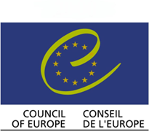
The cultural routes of the council of europe

Via Francigena

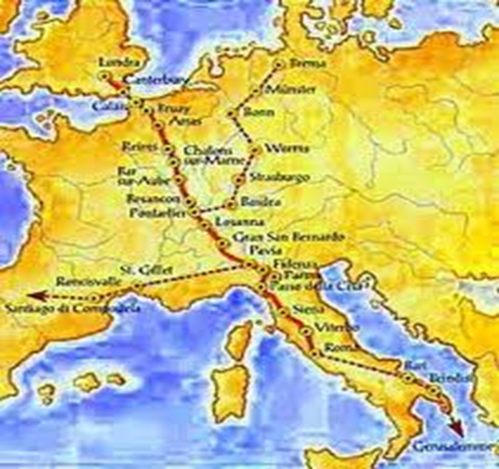

Claudia Mancini
Eleonora Magnarello
Maria Elena Uranoliti
Nicoletta Petrelli
OUTLINE

- MAIN FACTS

- ESSENTIAL DATA

- CONCLUSIONS

MAIN FACTS

The Via Francigena is a road of 1800 Km that rediscover the journey of piligrims through England, France, Switzerland and Italy. It honours the shared European cultural heritage like an expression of cultural diversity and identity, by linking together into a single itinerary.
The route wants to valorize the millenary pilgrimage route in order to promote measures for the development of the Via Francigena as a genuine tourism and cultural product, not only in the view of its cultural importance, but also in connection with its potential role as a catalyst for local development, with an emphasis on sustainability.
The canton of Valais in Switzerland established a touristic infrastructures and products on the Via francigena that communicate the unique cultural and historical heritage of the Route.
The Tuscany region, in Italy, is equally determined to develop cultural tourism along the Via Francigena that attracts a growing number of visitors every year.
Since 1994, the year in which the Via Francigena became a European Cultural Route, many associations and individuals have helped to promote the Route. In 2001 was founded the Italian Associazione dei Comuni Italiani that represents 34 municipalities and provincial administration in seven different regions. In 2006 the European Association of the Via Francigena was founded and, today, counts 95 European members.
This Route attracts the interest of regional and local authorities.
The sector covered are accommodation, attractions,
archaeological sites, creative industries, tours and visitor services. The main activity are: walking, hiking, trekking, pilgrimage, religion, cultural and natural heritage, historical paths and environment conservation, agriculture and regional development, culture and tradition of local people. This services and activities are available thanks to some partners, like tour operators, tourist offices, SMEs, non-profit organization, regional political bodies, etc.
In Italy, the Tuscany region has developed a regional master plan (an initiative aimed to developing the Via Francigena in a planned manner) and there are individual community that create important elements for development, and the communities are involved in funding.
Instead, in Switzerland, at local level, the Via Francigena is managed by both the Abbey St-Maurice and the Compagnons and the Via Francigena is financed by both the Valais and Vaud cantons and by the Swiss Government.

ESSENTIAL DATA

In Switzerland at least 75 SMEs and potentially 445 or more tourism-related business in the Valais region are directly connected to the Route; SMEs employ less than 250 person. In conclusion, an indeterminate number of jobs up to 111 250 could potentially depend directly or indirectly on tourism along the Via Francigena. The following table, show the numbers of SMEs in the different sectors:
 | Bookable package | Total
Accomodations | 18 | 86
Transport | 4 | 6
Restaurants | 18 | 139
Food supply | 22 | /
Agriculture/agriturism | 3 | n.s.
Attractions | 4 | 22
Retail, services | n.s. | 192
Tourist offices | - | 6

CONCLUSIONS

In conclusions the case study shows that: no data on the Via Francigena are available that would allow scientifically proved conclusions, in particular regarding the economic impact on SMEs along the Route; the absence of scientific approaches in establishing Cultural Routes; the lack of effective management structure to maintain cultural tourism projects and of the interconnection between SMEs and vertical organization and, finally, the lack of internal co-ordination leading to disadvantages for pilgrims.
The cultural Routes in Switzerland are required to meet the following criteria in order to be given Cultural Route Status:
- Includes the Inventory of Historical Traffic Routes in Switzerland;
- Includes the network of official hiking trails;
- Includes the UNESCO World Heritage sites;
- Includes regional and local specialities.

